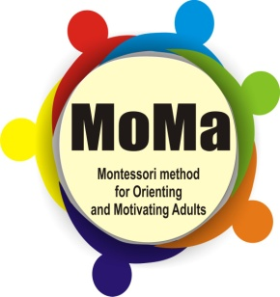
Montessori method for Orienting
and Motivating Adults - MOMA

Colegiul Tehnic de Transporturi si Constructii Iasi
Page 1

Project n. 527800-LLP-1-2012-1-IT-GRUNDTVIG-GMP
Mihaela Poroch – RO project manager
ENTER Month/year
Project n. 527800-LLP-1-2012-1-IT-GRUNDTVIG-GMP

Report
on the organization and development Seminars (workshops) 1 and 2

Location : Teacher Training Center
Date : March 21 and March 28, 2014
Organizing institution: Technical College of Transports and Constructions, Iasi
Participants : 2 experts in training adults (from School Inspectorate of Iasi and Psycho-pedagogical Assistance Center Iasi County) , RO project manager, 1 steering committee member, 3 psychologists, 7 teachers
Stake holders : Penitentiary of Iasi, School nr 41 of Iasi Penitentiary and General Directorate of Social Assistance and Child Protection Iasi - Adult disadvantaged section

- Tools : MOMA Project platform (E-consultation), Pedagogical model (translated in RO), flip chart + accessories, prezzi presentation, maps (with program, project description, pedagogical method, workloads portfolios, and handouts), video projector, daily evaluation questionnaires, PP presentation made by experts/trainers
- Strategies used in workshops: Brainstorming, Personal reflection and GLC - think, work and communicate in pairs
- Workshop evaluation - 9 daily evaluation questionnaires
- Evidences: table with signatures, PP presentation, photos, daily evaluation questionnaires

