MOMA

Montessori Method for Orienting and Motivating Adults
Agreement n. 2012- 4193/001 – 001 Project n. 527800-LLP-1-2012-1-IT-GRUNDTVIG-GMP

- Diffusion and Dissemination report –

The dissemination strategy is based on the fundamental assumption to make available the added value of project outcomes, optimizing and strengthening their impact and integration both in their original systems and contexts as well as in new ones. Within the MOMA project several dissemination arrangements have been set and implemented:
- Visual Identity - a unified image of the project was created through the realization of a common and shared visual identity. The visual identity includes the creation of project logo, templates in word and power point format, project website, leaflet, as well as guidelines to use them.
- Web-site - developed between 4-7 months of the project and it is in line with the European regulations on the use of websites as regards computer graphics, animation, sound and colour. It is developed in English and all partners’ languages. The website is a fundamental vehicle within the MOMA project that contains information and materials related with the project activities and results. The website address is: http://www.momaproject.eu/ The website address has been popularised in the following means:
TEAM: COORDINATOR: Centro Studi e Formazione Villa Montesca and partners:
Senior Universidade de Évora - Ass.
The Desenvolv. Comunitario, PT
Technical College of Transports and Constructions Iasi, RO
Health Psychology Management Organisation Services, UK
CHANCENGLEICH in Europe e.V., DE
Asociación de Personas Participantes Agora ES
The Public Institution Roma Community Centre, LT

- links of websites and screenshots of the websites where the project website has been diffused
- GERMANY
- Interview with Hella Klein – Expert MOMA – 28.May.2013
https://www.dropbox.com/s/uk5ld25odrjssnx/Film%20Interwiews%20-%20MOMA_09.08.13.mp4
- Interview with Tessa Zakrziwski
https://www.dropbox.com/s/uk5ld25odrjssnx/Film%20Interwiews%20-%20MOMA_09.08.13.mp4
- Chancengleich in Europa website – continuous update with information on the project
www.ch-e.eu
- Facebook site of Chancengleich in Europa
https://www.facebook.com/pages/CHANCENGLEICH-in-Europa-eV/234785309890156?ref=hl
- SPAIN
Link in the Adult School La Verneda-Sant Martí:
http://www.edaverneda.org/edaverneda/ca/projectes-europeus
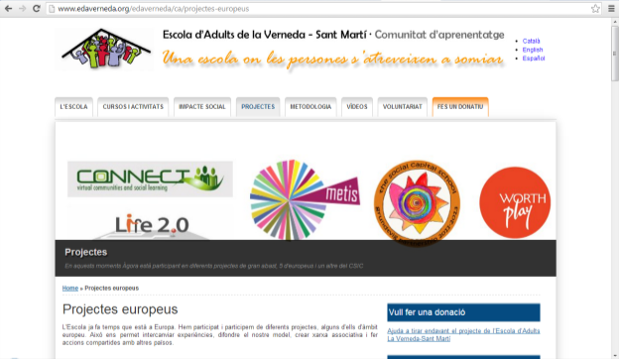
- PORTUGAL
- project presentation in PPT : 26.02.2013
- project presentation on the project in the municipality - 05 .03.2013
- Interview with Soraya Fernandes – expert
- New published in the “ Diario do Sul” newspaper - - 18.06.2013
- www.use.pt
- https://www.facebook.com/universidadesenior.evora?fref=ts
- Internal publication called “Viver Sénior” (editions of june and December)

ROMANIA
      - project presentation in prezi : 17.12.2012
http://prezi.com/mifjy-wql6ts/montesori-project/
      - project presentation on the site of School inspectorate - 27 .01.2013 .
      - proiecte.isjiasi@yahoo.com
      - Interview Matei Elena – expert MOMA - 12.11.2013 http://www.youtube.com/watch?v=DSwXEBdyhJk&feature=youtu.be
      - Interview Marius Vulpe – expert MOMA - 12.11.2013
http://www.youtube.com/watch?v=95k1nqpNTbQ&feature=youtu.be
- Article published in the “ Ziarul de Iasi” newspaper - - 24.07.2013
http://www.ziaruldeiasi.ro/invatamant/85-000-de-euro-pentru-trei-licee-din-iasi-care-deruleaza-un-parteneriat-pentru-invatare~ni8o2c
- Interview with experts
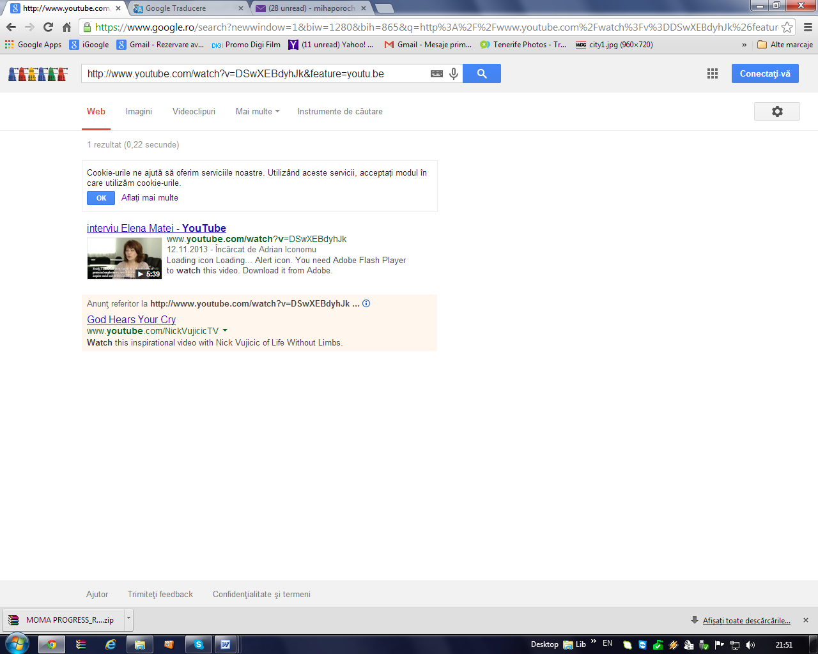
http://www.youtube.com/watch?v=DSwXEBdyhJk&feature=youtu.be
Interview Matei Elena – expert MOMA 12.11.2013

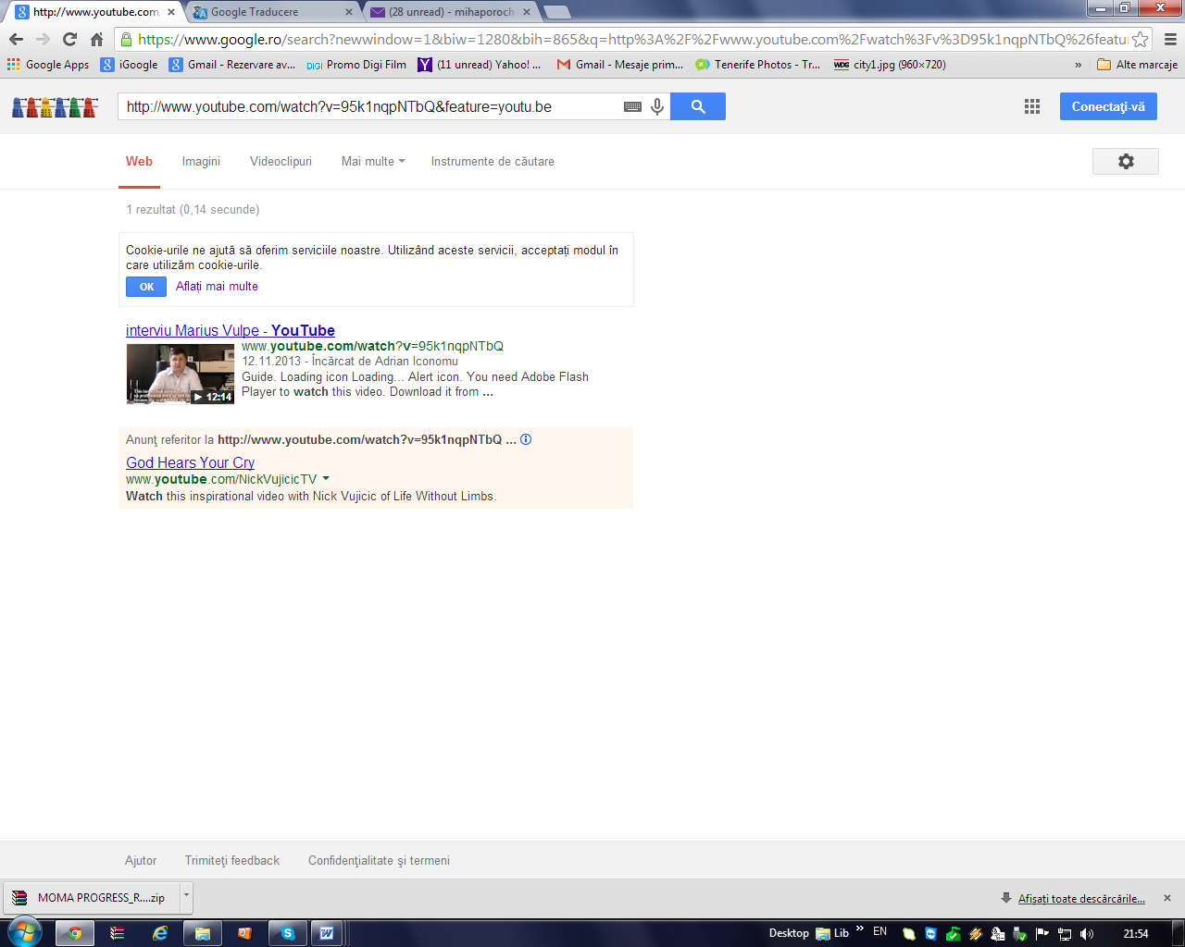
http://www.youtube.com/watch?v=95k1nqpNTbQ&feature=youtu.be
Interview Marius Vulpe – expert MOMA 12.11.2013

LITUANIA
- project presentation on the site of The Public Institution Roma Community Centre: 2012-12-22
http://www.roma.lt/v2/index.php?montessori-method-for-orienting-and-motivating-adult
- LT interview of expert , Vilnius Montessori pre-School director Ivona Rožanovska: 2013-11-18
http://www.youtube.com/watch?v=52pDRZpZlkM&feature=em-upload_owner
- LT interview of expert Daiva Drazdauskiene RCC teacher: 2013-12-09 http://www.youtube.com/watch?v=jqjxmqMyvLk&feature=youtu.be
- Lithuania National Research link published on website.
http://www.roma.lt/v2/index.php?montessori-method-for-orienting-and-motivating-adults

UNITED KINGDOM

1. Please see the link for public dissemination of - An Interview with Barbara Isaacs, the Academy Director, Montessori Centre International, UK : March, 2013.
http://www.youtube.com/watch?v=gtd9IOLGxWQ

2. Project interview presentation for public dessimination of the Summary of an Interview with Barbara Isaacs, the Academy Director, Montessori Centre International, UK. March, 2013.
https://drive.google.com/file/d/0B0HIFt25M_o-dmR1RFUxVnEzcHc/edit?usp=sharing

3. Please see the link for public dessimination of HP-MOS Research: UK Research/Survey of Social and Cultural Barriers to "ALTERNATIVE" ADULT Education for people with varying disabilities and special needs. April, 2013.
https://drive.google.com/file/d/0B0HIFt25M_o-a2x5d0dLMHItdDg/edit?usp=sharing
4. Please see the link for public dessimination of HP-MOS Research: UK Research/Survey of Montessori Methods with ADULTS AND CHILDREN APPROACH. April, 2013.
https://drive.google.com/file/d/0B0HIFt25M_o-Wk01QnRuX1ZBZjA/edit?usp=sharing

5. Please see the link for public dessimination of HP-MOS Newsletters 1 & 2 for the MOMA project.
May - June 2013
https://drive.google.com/file/d/0B0HIFt25M_o-M3Jaa0UzUlVBMkE/edit?usp=sharing
https://drive.google.com/file/d/0B0HIFt25M_o-RHlCdS1hSGQwMTA/edit?usp=sharing

- Newsletters - addressed to stakeholders and with the aim of making activities and results as much diffused and available as possible. Till now there were issued … numbers of the MOMA project newsletters. They are elaborated in English and all partners’ languages.
- table mentioning where the newsletters have been distributed (repeat as many lines as necessary):
GERMANY
Organisation | Location/ address | Date distributed
Chancengleich in Europa e.V. website | www.ch-e.eu | July 2013
Sarah Weller  JobCenter Dortmund | Sarah.Weller@jobcenter-ge.de | August 2013
Ümit Kocan  VMDO Dortmund | uekosan@vmdo.de | August 2013
Jutta Neteler  Multikulturelles Forum Lünen | neteler@multikulti-forum.de | August 2013
Hella Klein  Montessori Pedagogue and Teachers Trainer | Klein.hella@t-online.de | August 2013
Andrea Große- Wiesmann  LVR-Berufskolleg  Fachschulen des Sozialwesens, Düsseldorf | Andrea.Grosse-Wiesmann@lvr.de | August 2013
Deutsche Montessori Gesellschaft e.V. | dmg@deutsche-montessori-gesellschaft.de | August 2013
Montessori Dachverband Deutschland e.V. | kontakt@montessori-deutschland.de | August 2013
Gunther Niermann  Der Paritätische Northrhein-Westfalia, Dortmund | niermann@paritaet-nrw.org | August 2013
Ute Lohde  GrünBau-Die gemeinnützige Gesellschaft für soziale Beschäftigung und Qualifizierung in der Stadterneuerung, Dortmund | ulohde@gruenbau-dortmund.de | August 2013
Stefan Buchholt  Landesweite Koordinierungsstelle Kommunale Integrationszentren (LaKI) | stefan.buchholt@bra.nrw.de | August 2013
Miriam Weilbrenner  Koordinierungsstelle Kommunale Integrationszentren (LaKI) | miriam.weilbrenner@bra.nrw.de | August 2013
Christa Behrens  Erwachsenenbildungswerk Westfalen und Lippe eV | christa.behrens@ebwwest.de | August 2013

PORTUGAL
Organisation | Location/ address | Date distributed
Universidade Sénior de Évora | The first newsletter was sended to all institutions contacts using our email (usevora@gmail.com) in order popularized the project to our learners, partners and other institutions about the project existence and development | July 2013
Instituto Cultural de Évora | Évora | September 2013
Evora Municipality | Évora | September 2013
Academia EvoraJovem | Évora | September 2013
Fundação Eugénio de Almeida | Évora | September 2013
Megaexpansão | Caldas da Rainha | September 2013
Mundus Intercultural | Évora | September 2013
Rutis | Almeirim | September 2013
Junta de Freguesia da Sra da Saúde | Évora | September 2013
Junta de Freguesia da Horta das Figueiras | Évora | September
Junta de Freguesia de Bacelo | Évora | September
Associação Académica da Universidade de Évora | Évora | September
Universidade Sénior de Évora | The second newsletter was sended to all institutions contacts using our email (usevora@gmail.com) in order popularized the project to our learners, partners and other institutions about the project existence and development | October 2013
Instituto Cultural de Évora | Évora | October 2013
Evora Municipality | Évora | October 2013
Academia EvoraJovem | Évora | October 2013
Fundação Eugénio de Almeida | Évora | October 2013
Megaexpansão | Caldas da Rainha | October 2013
Mundus Intercultural | Évora | October 2013
Rutis | Almeirim | October 2013
Junta de Freguesia da Sra da Saúde | Évora | October 2013
Junta de Freguesia da Horta das Figueiras | Évora | October 2013
Junta de Freguesia de Bacelo | Évora | October 2013
Associação Académica da Universidade de Évora | Évora | October 2013
Universidade Sénior de Évora | The third newsletter was sended to all institutions contacts using our email (usevora@gmail.com) in order popularized the project to our learners, partners and other institutions about the project existence and development | December 2013
Instituto Cultural de Évora | Évora | December 2013
Evora Municipality | Évora | December 2013
Academia EvoraJovem | Évora | December 2013
Fundação Eugénio de Almeida | Évora | December 2013
Megaexpansão | Caldas da Rainha | December 2013
Mundus Intercultural | Évora | December 2013
Rutis | Almeirim | December 2013
Junta de Freguesia da Sra da Saúde | Évora | December 2013
Junta de Freguesia da Horta das Figueiras | Évora | December 2013
Junta de Freguesia de Bacelo | Évora | December 2013
Associação Académica da Universidade de Évora | Évora | December 2013

ROMANIA
Organisation | Location/ address | Date distributed
Ziarul de Iasi, RO | http://www.ziaruldeiasi.ro/invatamant/85-000-de-euro-pentru-trei-licee-din-iasi-care-deruleaza-un-parteneriat-pentru-invatare~ni8o2c | July, 24 2013
County School Inspectorate of Iasi, RO | The first newsletter was posted on the proiecte.isjiasi@yahoo.com MOMA project popularization and stimulating teachers and schools for their involvement in the development and future European activities | November,21 2013
ANFPCDEFP - National Agency for Community Programs for Education and Professional - Florentina Anghel – responsible Development, RO | Article “Adult Education in Romania” on yahoo grundtvigers  groups.yahoo.com/group/grundtvigers/message/5333‎ | February, 10 2013
MOMA presentation in prezzi on on 17 December 2012, by Mihaela Poroch, RO | . http://prezi.com/mifjy-wql6ts/montesori-project/ | 17 December 2012
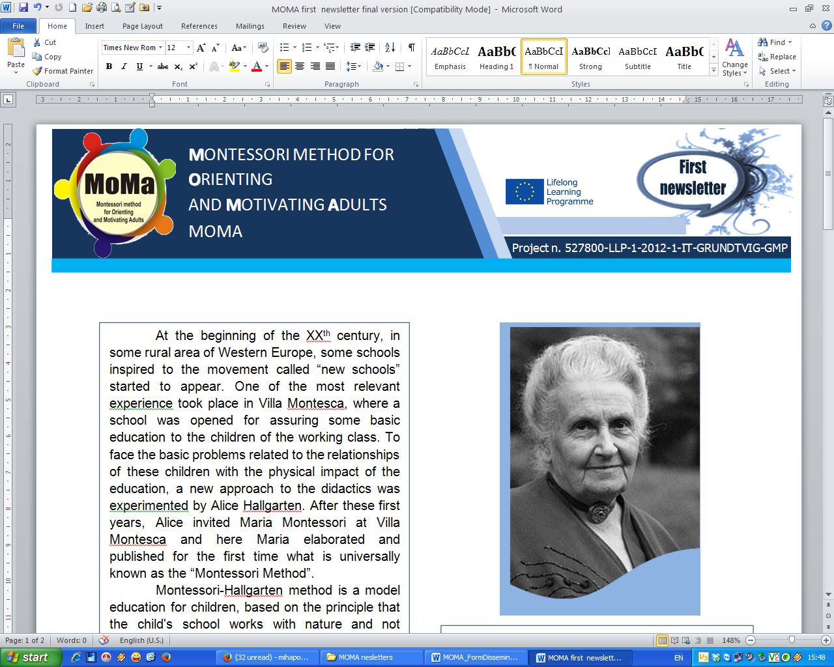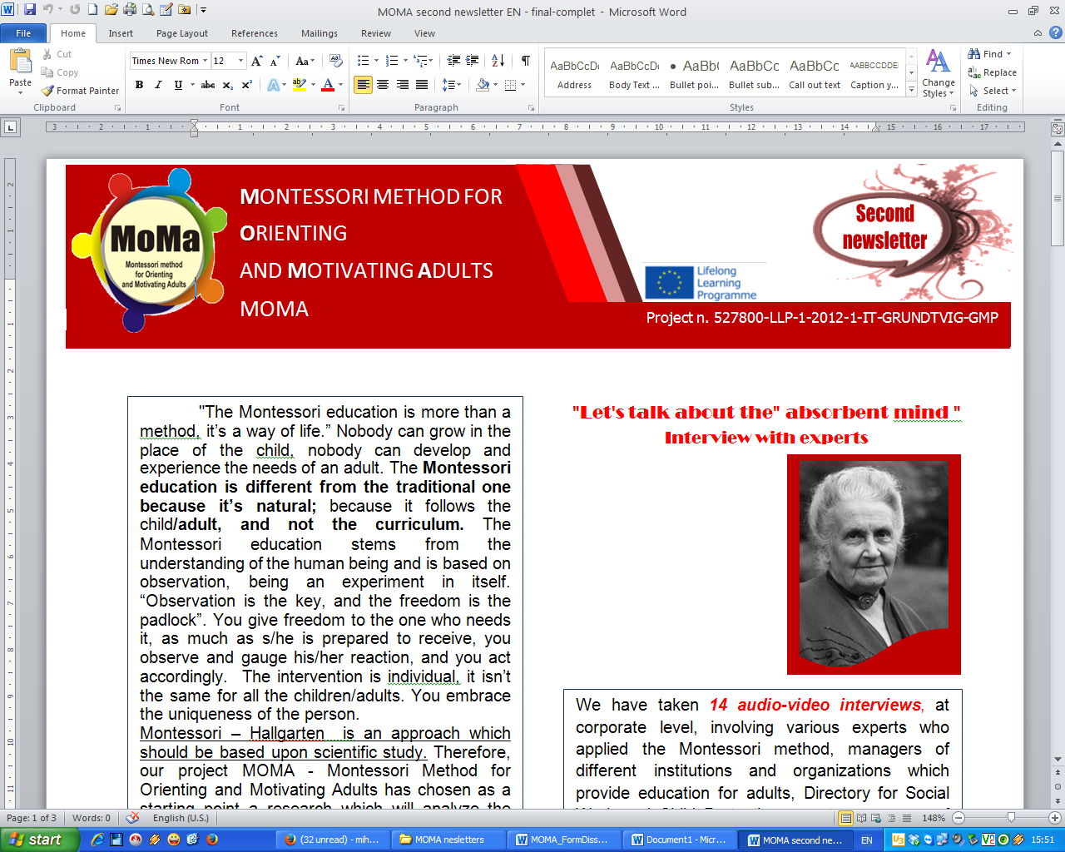
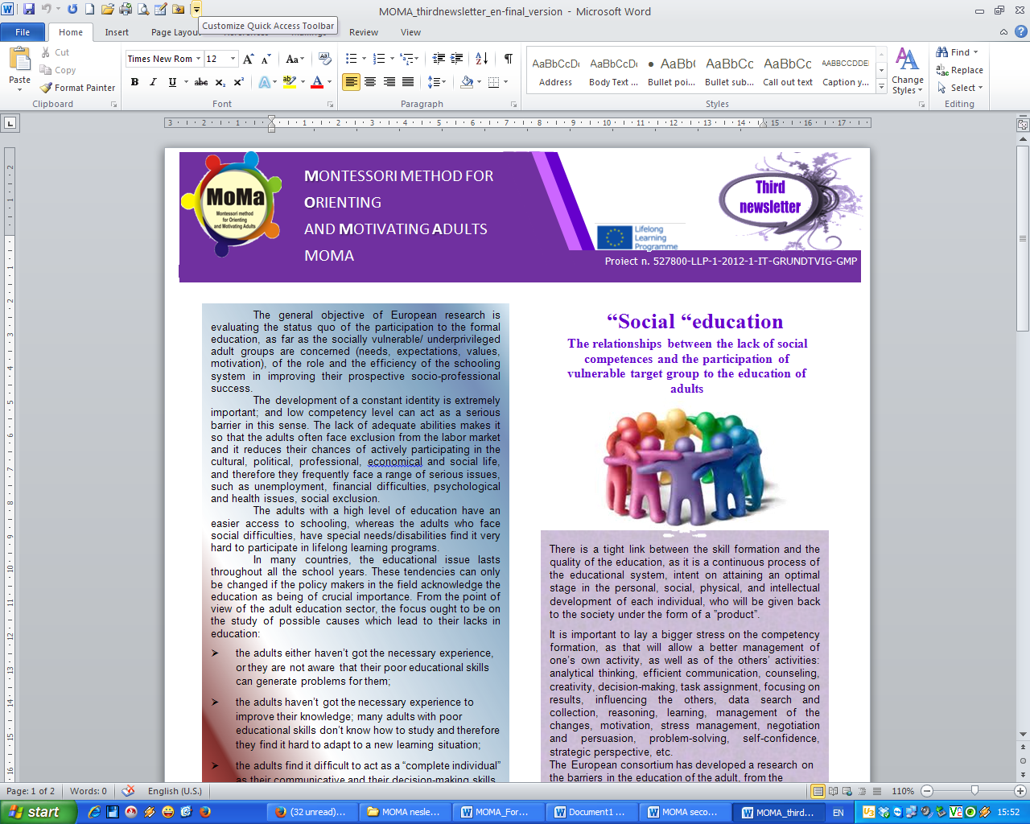

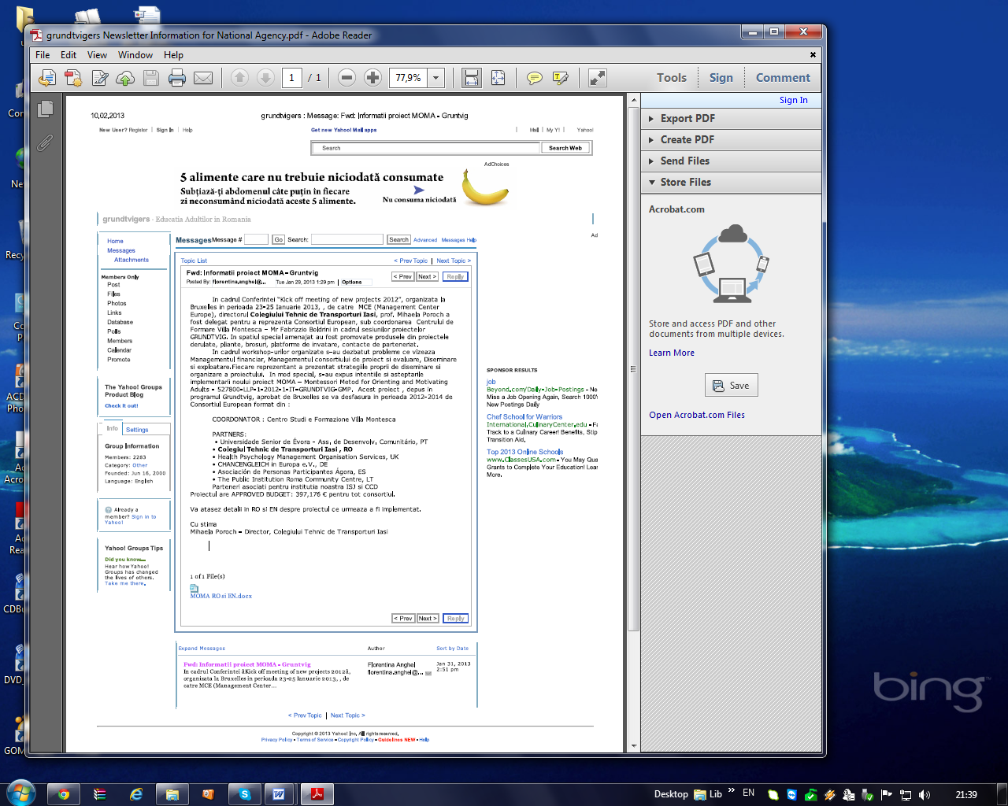
Article posted on Yahoo grundtviger, 10.03.2013 posted by Florentina Anghel – Grundtvig program coordinator, from National Agency on 29.01.2013

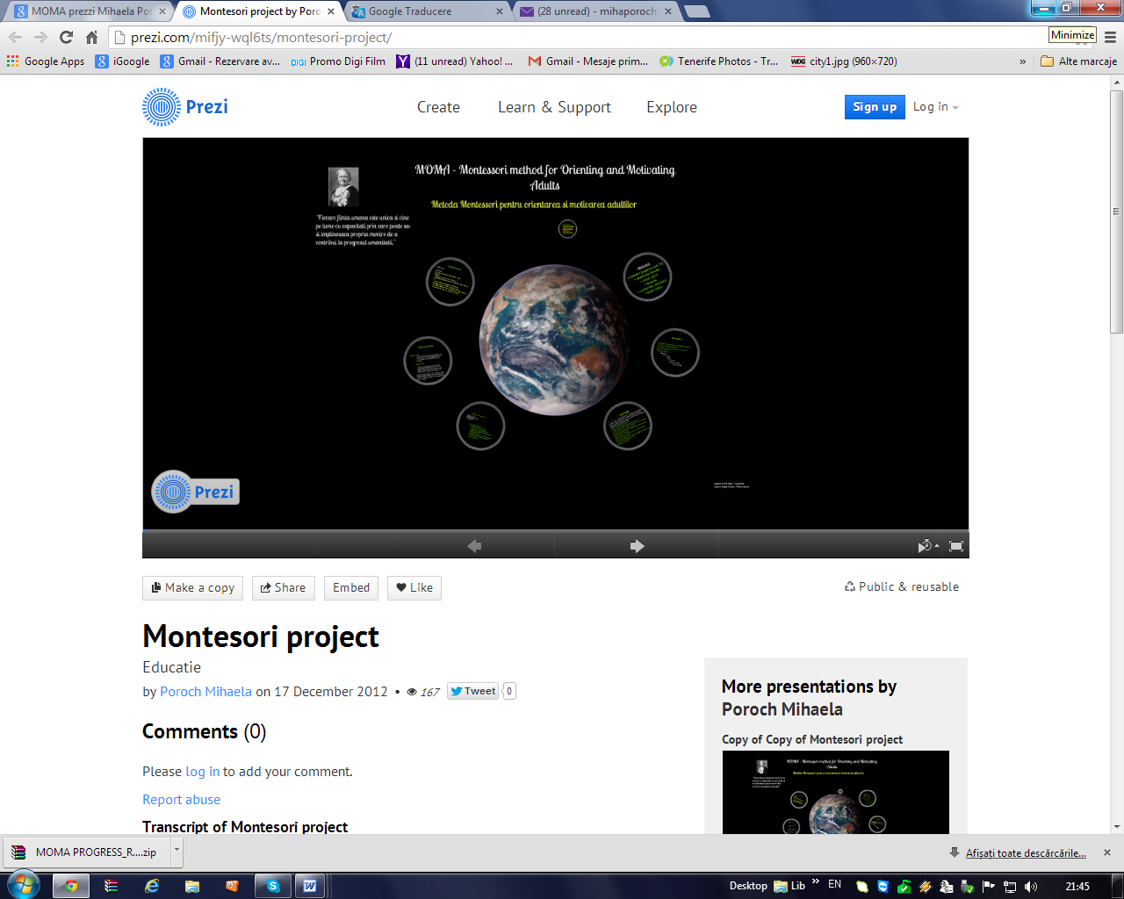
MOMA presentation in prezzi on on 17 December 2012, by Mihaela Poroch http://prezi.com/mifjy-wql6ts/montesori-project/
UNITED KINGDOM

Organisation | Location/ address | Date distributed
Health Psychology Management Organisation Services | Internal Organisation (20 stakeholders)  Address: Knowledge Dock Business Center Docklands Campus 4-6 University Way, London E16, 2RD | Paper based distribution activities August,2013
London Borough of Barking and Dagenham Council | Public stakeholders from health and social care organisation (printed 1000 copies for distribution)  Address: Civic Centre, Rainham Road North, Dagenham, RM10 7BN, London | Paper based distribution activities September,2013
London Borough of Havering Council | Public stakeholders from health and social care organisations (printed 1000 copies for distribution)  Address: Town Hall, Main Road, Romford, RM1 3BD, London | Paper based distribution activities September, 2013
City of Westminster Council | Public stakeholders from health and social care organisations (printed 1000 copies for distribution)  Address : Westminster City Hall, 64 Victoria Street, London, SW1E 6QP. | Paper based distribution activities November, 2013
University of East London | University stakeholders from three campuses (printed 1000 copies for distribution)  Addresses:  University of East London, Docklands Campus  University Way, London, E16 2RD  University of East London, Stratford Campus  Water Lane, London, E15 4LZ  University of East London  University Square Stratford  1 Salway Road, London, E15 1NF | Paper based distribution activities November, 2013
Leaflet: The leaflets contain the project aims and the references of all the partners involved. There were/will be disseminated during the national conferences, the national press conferences, the national meetings, seminars with the project stakeholders, the final conference, and also during other partners events not directly linked to the MOMA Project.
LITUANIA
Organisation | Location/ address | Date distributed
There are informed the Roma themselves, because they are members of the target groups, as well as to inform community leaders. | Kirtimai, roma community settlement. Vilnius | During the project period
First newsletter link published on The Public Institution Roma Community Centre website | http://www.roma.lt/v2/index.php?montessori-method-for-orienting-and-motivating-adults | 30.11.2013
Ministry of Culture of Lithuania | Basanaviciaus 5, Vilnius | 29.11.2013
Lithuanian Children’s Fund | Workshop for Roma organisations, Villa Alicante, Vilnius | 21.11.2013
Lithuanian Gypsy Association "Gypsy Fire" | Geologu 6, Vilnius | 26.11.2013

- table mentioning where the leaflets have been distributed (repeat as many lines as necessary):

PORTUGAL
Organisation | Location/ address | Date distributed | Number of copies
Municipality of Évora | Praça do Sertório, Evora | 10/2013 | 300
Universidade Sénior de Évora | Rua Fernanda Seno, 20 B - Évora | 10/2013 | 150
Junta de Freguesia da Horta das Figueiras | Rua Fernanda Seno, 12 - Évora | 10/2013 | 75

ROMANIA
Brochure and leaflet distributed
Organisation | Location/ address | Date distributed | Number of copies
Technical College of Transports | Socola 82 | October, 10, 2013 | 10 brochure and 22 leaflets
Teacher Training Center | Str. Octav Botez, Nr. 2A Iasi | September, 26, 2013 | 2
County School Inspectorate of Iasi | Strada Nicolae Bălcescu, nr. 26. Judeţul Iaşi | September 26, 2013 | 3
Penitenciary of Iasi | 10, Dr. Vicol street | October, 11 2013 | 1
General Directorate for Assistance and Protection | 57 A, Vasile Lupu, street | October, 11, 2013 | 1
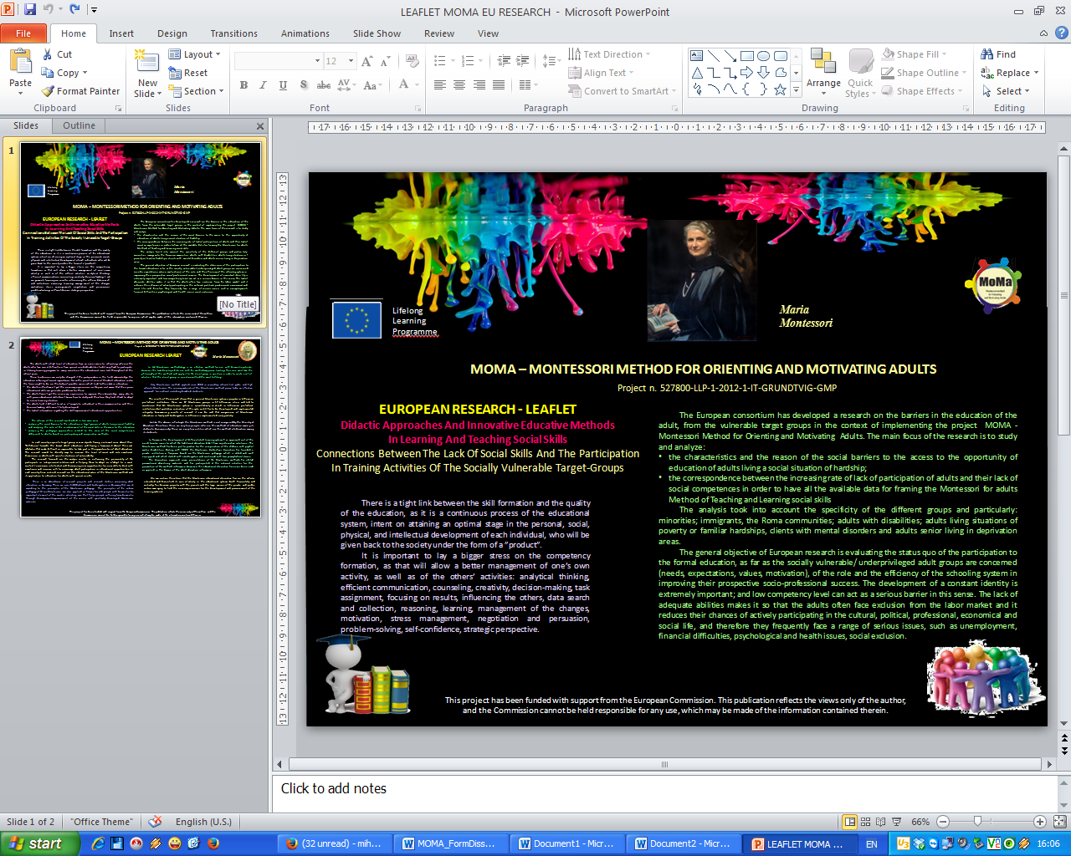
EU leaflet
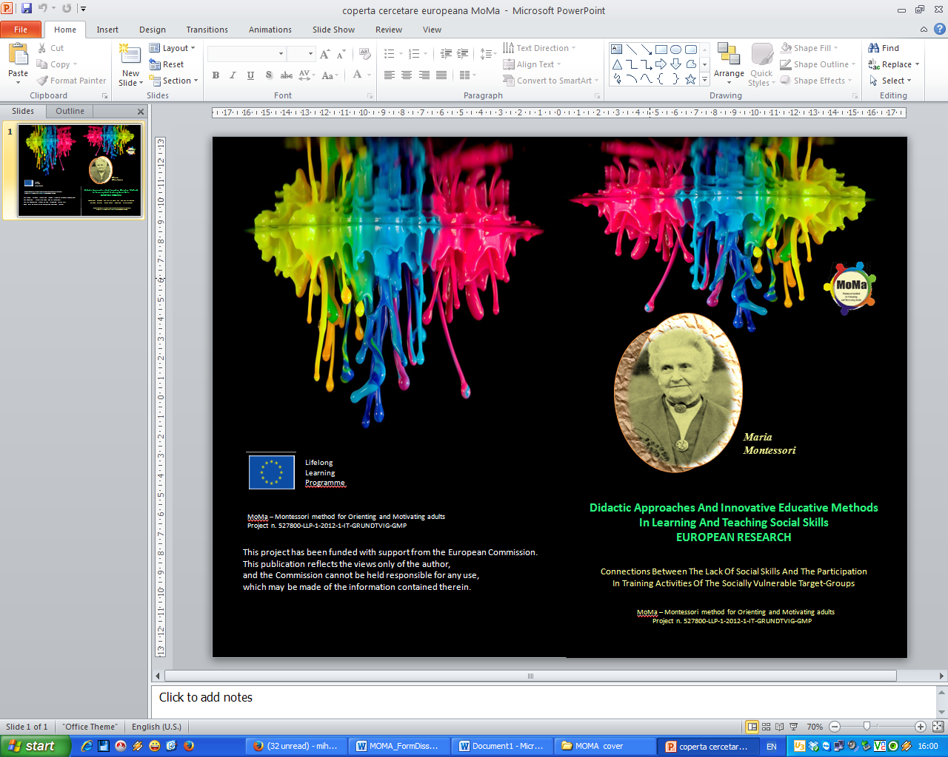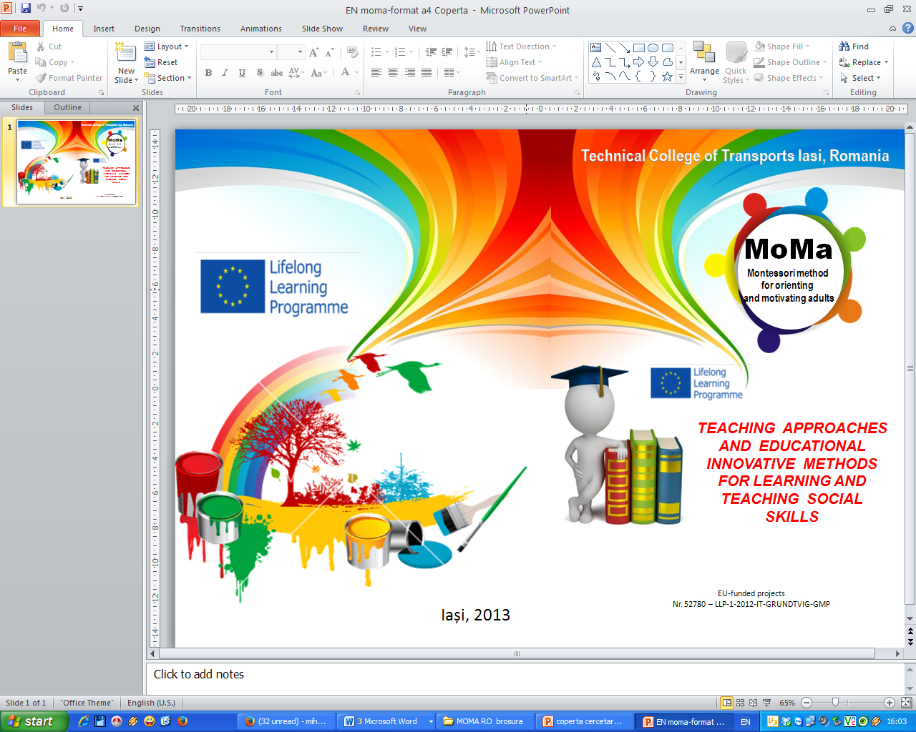
BROCHURE with EU research BROCHURE with Romanian research
UNITED KINGDOM

Organisation | Location/ address | Date distributed | Number of copies
Health Psychology Management Organisation Services | Knowledge Dock Business Center Docklands Campus 4-6 University Way, London E16, 2RD | October 2013 | Paper based distribution activities.  (5 brochure and 20 leaflets
London Borough of Camden Council | Town Hall, Judd Street, London, WC1H 9JE | September 2013 | Paper based distribution activities  (300 leaflets)
London Borough of Hackney Council | Town Hall, Mare Street, London E8 1EA | September 2013 | Paper based distribution activities  300 (leaflets)
London Borough of Newham Council | Newham Dockside, 1000 Dockside Road, London, E16 2QU | October 2013 | Paper based distribution activities  300 (leaflets)
London Borough of Redbridge Council | Town Hall, High Road, Ilford, IG1 1DD | November 2013 | Paper based distribution activities  300 (leaflets)

- National meetings /conferences: one National conference in each country is foreseen. These are be an opportunity to inform national media (television, newspapers), decision makers and stakeholders. Each partner can spread promotional materials in its own language and in English with information about the activities and the results achieved, especially concerning the experimentation phase.
- table mentioning where the conference will take place /has been taking place (repeat as many lines as necessary):
GERMANY
Event | Location | Number of invitees/ attendees | Date of event  (foreseen)
Seminar | Alevi community Center Dortmund | PP/10 participants | 5. Dec. 2012
Seminar | University of Dortmund | PP/25 participants | 14. Dec 2012
PV Training Seminar –trainers from different educational centers | Chancengleich in Europa e.V:, Dortmund | PP/15 participants | 3-5 January 2013
Intercultural Sensitiation Training for staff member of JobCenters in the district | Educational Center  Multi Kulti, Lünen | PP/18 participants | 31 January  27-28 February
Presentation of the MoMa Project in different European projects of CHANCENGLEICH | In Dortmund and in different MS | PP/80 participants and steakholders | During the project period
Presentation and dissemination of the MoMa activities and results within a group of pedagogues from Germany and Iceland (Leo.-Mob.). Representatives of different educational associations in Dortmund | CH-E In Germany and Iceland | PP/40 pedagogues and steakholders | 23-30 March 2013
Meeting with Stadtteilagentur/local agency for the Dortmund Suburb Hörde | Dortmund Hörde | 5/verbal | 9 April 2013
Presentation of project results in a meeting with the Vocational Educational Center  Gesellschaft für Bildung und Beruf e.V. | Gesellschaft für Bildung und Beruf, Dortmund | 7/verbal | 10 April 2013
Meeting with representatives of the Muslim community in Dortmund-Hörde | Dortmund | 3 steakholders/pp | 27 April 2013
Presentation of the project and report about the activities in a membership meeting of CHANCENGLEICH in Europa e.V | Dortmund | PP/16 members | 25. April 2013
Meeting with a representative of the association EWZ in Dortmund | Dortmund | 3 staff members/pp | 4 May 2013
Calls with different Montessori associations in Germany, presenting the idea of the MOMA project and asking for cooperation | Germany | Ca. 20 | In May
Meeting with representatives of the association Soziale Innovation in Dortmund | CH-E, Dortmund | 3 staff members/pp | 18 June 2013
Presentation in the city council of Schwerte (neighborhood city) | Rathaus Schwerte/Frau Birgit Wippermann/Equality officer | 2/verbal | 20 June 2013
Conference about Europe and future of Europe. Participants were a.o. Membes oft he European Parliament and the Parliament of Northrhein Westfalia.  CHANCENGLEICH had a presentation stand in the conference. | Europe – direct – Informationszentrum in Dortmund, Rathaus Dortmund | Ca. 250/ stand presentation | 21 June 2013
Meeting with representatives of „Der Paritätische“ an umbrella organization, a community of solidarity, uniting different and independent initiatives, organisations and institutions from a broad spectrum of social work. | Der Paritätische Gesamtverband, Dortmund | 2 steakholders | 26 June 2013
Hörder Brückenfest/ Street festival | Dortmund | Ca. 5000visitors/ | 29 June
Symposium/Interkulturelle Öffnung in Migrantenorganisationen | Dortmund Hörde | 70 visitors/verbal | 11 Juli
Meeting with managers of the Job Center in Dortmund | Dortmund/Dietrich Keuninghaus | 2 steakholders/pp | 20 August
Conference in Dortmund about the Participatory Video Method….+ presentation of the MOMA Method | Bürgersaal /Community Center Dortmund Hörde | 50/ | 26 August 2013
Training Seminars in different Migrant Associations in Dortmund e.g. African Tide, Haali Pulaar, AGASCA, Tamil Association | VMDO e.V. (Migrant umbrella assocaition)  Dortmund | 60/ participants | September - October 2013
Presentation of project results in conference of the „Der Paritätische“ in Bochum | IFAK e.V. Bochum | 22/ | 26 September
Presentation and dissemination of the MoMa activities and results within a group of pedagogues from Germany and Hungary (Leo.-Mob.). Representatives of different educational associations in Dortmund | CHANCENGLEICH in Europa e.V., Dortmund, and Hungary | PP/40 pedagogues and steakholders | 29 September -  6 October 2013
Meeting with representatives of the umbrella organization and discussion about the new Montessori Method and how to present if for member associations and how to use it in Trainings with disadvantaged groups | Der Paritätische - Dortmund | 3 steakholders | 7 November
Meeting with representatives of the Job Center, Discussion about the new Montessori Method and how to use it in Trainings with disadvantaged groups | JobCenter Dortmund | 4 steakholders | 14 November

PORTUGAL
Event | Location | Number of invitees/ attendees | Date of event  (foreseen)
Transnational Meeting in Évora | Évora | 25 | May 2013
ROMANIA
Event | Location | Number of invitees/ attendees | Date of event  (foreseen)
National Conference | Teacher Training Centre of Iasi | 50 (41 persons took part) | September, 26 2013
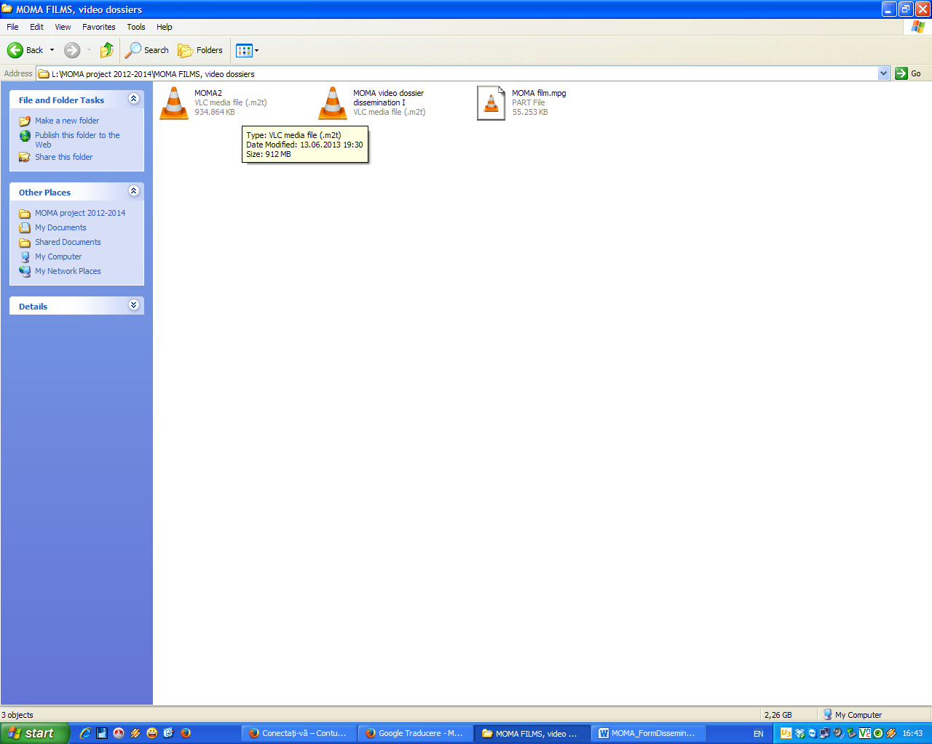
Video dossier – step-by-step European dissemination

UNITED KINGDOM

Event | Location | Number of invitees/ attendees | Date of event  (foreseen)
National Conference/Event | Barking and Dagenham Council of Voluntary Services (UK) | The mayor, his team and the general public (Over 1000 attended this event/conference. | September, 2013
News releases and press conferences - these are used to inform international, national and local mass-media about project dissemination activities such as open working tables. In every partner’s meeting a press conference will be organized.
- table mentioning where the press releases will /have been published (repeat as many lines as necessary):
LITUANIA
Event | Location | Number of invitees/ attendees | Date of event  (foreseen)
International  Conference-Discussion  “Implementation of the National Roma Integration Strategies in the European Union Member States“ in connection with the Lithuanian Presidency of the European Union Council in 2013 | Hotel Conti  Raugyklos str. 7 Vilnius | 100 | 07.11.2013
The Annual meeting of RCC founders: Ministry of Culture of Lithuania, Vilnius Municipality, Lithuanian Children’s Fund and Lithuanian Gypsy Association "Gypsy Fire | RCC, Vilnius | 10 | 26.04.2013
Meeting with participants of International SOCIAL PLATFORM networking conference on “Social investment under the Lithuanian EU Presidency” building alliances between European and Lithuanian social civil society organisations | Artis Centrum Hotel,  RCC, Vilnius | 17 | 23/05/2013
Meeting with representatives of German Trade Union of Social workers | RCC, Vilnius | 12 | 30.09.2013
Meeting with representatives of Lithuanian Association of Education | RCC, Vilnius | 10 | 06.10.2013

PORTUGAL
Publication title | Contact person | Contact point /website address | Publication date
Universidade Senior de Évora acolhe parceiros de projecto europeu | Paulo Piçarra | www.diariodosul.pt | June 2013

- Publication of the project results in specialized and non-specialized local and foreign journals: publishing project results in non-specialized journals can get a wider audience of potential users and audience interested in MOMA contents and objectives
- table mentioning where the articles will /have been published (repeat as many lines as necessary):
ROMANIA
Publication title | Contact person | Contact point /website address | Publication date
“ Ziarul de Iasi” newspaper | Loredana Oprea | http://www.ziaruldeiasi.ro/invatamant/85-000-de-euro-pentru-trei-licee-din-iasi-care-deruleaza-un-parteneriat-pentru-invatare~ni8o2c | July, 24 2013

UNITED KINGDOM
Publication title | website address | website location | Publication date
Post Graduate Forum | http://www.postgraduateforum.com/thread-23685/?pageNo=2#message224378 |  | December 2013
Uncommon Forum | http://www.uncommonforum.com/viewtopic.php?p=779399#779399 |  | December 2013
The Student Room Forum | http://www.thestudentroom.co.uk/showthread.php?t=2544262&p=45613897#post45613897 |  | December 2013
HP-MOS Thoughts (Blog) | http://hp-mos.thoughts.com/posts/montessori-method-for-orienting-and-motivating-adults |  | December 2013
The Well Trained Community Forum | http://forums.welltrainedmind.com/topic/498282-montessori-method-for-orienting-and-motivating-adults/#entry5372433 |  | December 2013

If there are any other areas/ways that you disseminated the project, please list them in the box that follows.
GERMANY
Radio broadcast in the local radio Dortmund 91.2 | Hans Schreiber. presemter | 8 October | Dortmund Eving | Listeners ca. 15000

SPAIN
1 | Pedagogic Gathering about P. Freire’s book: “A la sombra de este árbol” to talk about adult education | 05/11/2013 | Asociación de personas participantes Ágora
2 | Training workshop on adult education | 10/09/2013 | Asociación de personas participantes
3 | Training workshop on adult education | 17/09/2013 | Asociación de personas participantes
4 | Training workshop on adult education | 01/10/2013 | Asociación de personas participantes
5 | Training workshop on adult education | 29/10/2013 | Asociación de personas participantes
6 | Training workshop on adult education | 27/11/2013 | Asociación de personas participantes
7 | Training workshop on adult education | 10/12/2013 | Asociación de personas participantes

PORTUGAL
- Participation in the municipal presentation of the Program “laços para a vida” (Bows to life) that took place in Évora on the 30th of January. This program intends to include young and older people in volunteering. The MOMA project was mentioned as an example of readjusting a child method to adults and with an inclusive approach.
The project is describe on http://www.cm-evora.pt/pt/conteudos/areas%20tematicas/Educa%C3%A7%C3%A3o%20e%20A%C3%A7%C3%A3o%20Social/Projecto%20%20Lacos%20para%20a%20Vida%20%20Casa%20%20%20Companhia.htm
- Participation in the annual magna reunnion of the network of senior universities. The event was held on 18th October in Almeirim. A presentation of the project was made for all the senior universities representatives. http://rutis.pt/

ROMANIA
Location: Teacher Training Center, on May, 29-30, 2013 Even : Workshop Project living/ A paradigm, two training systems: Anglo Saxon and Romanian: Video dossier step by step, program, list with 29 participants with signature and application form

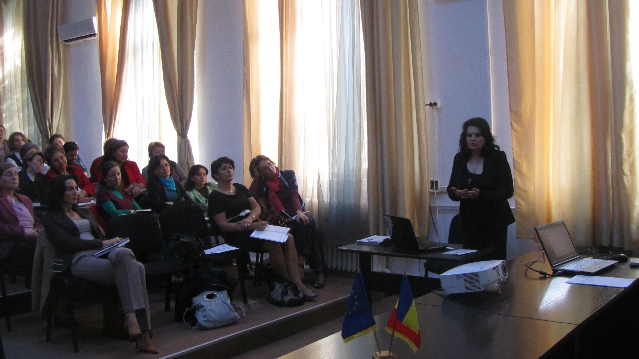
Application form for the presentation of the project at Teacher’s Training Center, May, 29-30, 2013 Workshop Project living/ A paradigm, two training systems: Anglo Saxon and Romanian

For each of the activities above described and for which there are available supporting documents (brochures, leaflets, magazines, journals, photos, videos, signatures, web pages, etc…..), please copy them in the table here below and provide the description requested. Repeat the table as many times as necessary. (send also in attachment the supporting documents)
GERMANY
Activity type
Conference about Europe and future of Europe.
Date of the activity
21.06.2013
Location
Europe – direct – Informationszentrum in Dortmund, Rathaus Dortmund
Description of the activity
Conference about Europe and the future of Europe.
CHANCENGLEICH had a presentation stand in the conference.
Participants
Ca. 250, among them Membes oft he European Parliament and the Parliament of Northrhein Westfalia
Evidences
Photos
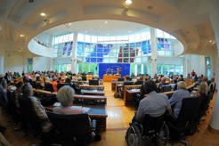

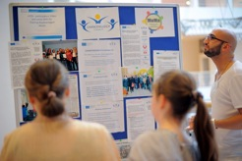

SPAIN
Activity type
Pedagogic Gathering about P. Freire’s book: “A la sombra de este árbol” to talk about adult education
Date of the activity
05/11/2013
Location
Asociación de personas participantes Ágora. Adult School La Verneda-Sant Martí. Barcelona.
Description of the activity
We have disseminated the project and contact staff and volunteer members of the adult school La Verneda-Sant Martí in order to invite them to participate in the E-consultancy and on-line Workshop. To do that, we have organized a pedagogic gathering to discuss about Paulo Freire’s book “A la sombra de este árbol” as a way to introduce the MOMA method in adult education.
Participants
20 people participated in this pedagogic gathering.
Evidences: N/A

Activity type
Training workshop on adult education
Date of the activity
10/09/2013
Location
Asociación de personas participantes Ágora. Adult School La Verneda-Sant Martí. Barcelona.
Description of the activity
Àgora has organized and carried out 6 training workshops on adult education in the period September-November 2013 addressed to staff and volunteer members of the Association. These workshops have focused on adult education and has been conceived as a general introduction to the importance of education and a first step to know how to work and address to adult people in basic education. A first introduction to the MOMA project has been presented to the group.
Participants
10 people have participated in this workshop.
Evidences: N/A

Activity type
Training workshop on adult education
Date of the activity
17/09/2013
Location
Asociación de personas participantes Ágora. Adult School La Verneda-Sant Martí. Barcelona.
Description of the activity
Àgora has organized and carried out 6 training workshops on adult education in the period September-November 2013 addressed to staff and volunteer members of the Association. These workshops have focused on adult education and has been conceived as a general introduction to the importance of education and a first step to know how to work and address to adult people in basic education. A first introduction to the MOMA project has been presented to the group.
Participants
10 people have participated in this workshop.
Evidences: N/A

Activity type
Training workshop on adult education
Date of the activity
01/10/2013
Location
Asociación de personas participantes Ágora. Adult School La Verneda-Sant Martí. Barcelona.
Description of the activity
Àgora has organized and carried out 6 training workshops on adult education in the period September-November 2013 addressed to staff and volunteer members of the Association. These workshops have focused on adult education and has been conceived as a general introduction to the importance of education and a first step to know how to work and address to adult people in basic education. A first introduction to the MOMA project has been presented to the group.
Participants
7 people have participated in this workshop.
Evidences: N/A

Activity type
Training workshop on adult education
Date of the activity
29/10/2013
Location
Asociación de personas participantes Ágora. Adult School La Verneda-Sant Martí. Barcelona.
Description of the activity
Àgora has organized and carried out 6 training workshops on adult education in the period September-November 2013 addressed to staff and volunteer members of the Association. These workshops have focused on adult education and has been conceived as a general introduction to the importance of education and a first step to know how to work and address to adult people in basic education. A first introduction to the MOMA project has been presented to the group.
Participants
3 people have participated in this workshop.
Evidences: N/A

Activity type
Training workshop on adult education
Date of the activity
27/11/2013
Location
Asociación de personas participantes Ágora. Adult School La Verneda-Sant Martí. Barcelona.
Description of the activity
Àgora has organized and carried out 6 training workshops on adult education in the period September-November 2013 addressed to staff and volunteer members of the Association. These workshops have focused on adult education and has been conceived as a general introduction to the importance of education and a first step to know how to work and address to adult people in basic education. A first introduction to the MOMA project has been presented to the group.
Participants
5 people have participated in this workshop.
Evidences: N/A

Activity type
Training workshop on adult education
Date of the activity
10/12/2013
Location
Asociación de personas participantes Ágora. Adult School La Verneda-Sant Martí. Barcelona.
Description of the activity
Àgora has organized and carried out 6 training workshops on adult education in the period September-November 2013 addressed to staff and volunteer members of the Association. These workshops have focused on adult education and has been conceived as a general introduction to the importance of education and a first step to know how to work and address to adult people in basic education. A first introduction to the MOMA project has been presented to the group.
Participants
5 people have participated in this workshop.
Evidences: N/A

PORTUGAL
Activity type
Meeting for the partnership / collaboration protocols with different institutions, corresponding to the target group of the project
Date of the activity
March, 2013; October 2013, November 2013
Location
Universidade Sénior de Évora
Camara Municipal de Évora
Description of the activity
Developing collaboration with institutions involved (stakeholders)
- Camara Municpal de Évora (city councilwomen + 1 persons)
- Junta de Freguesia (president + 1 persons)
- GARE (2 persons)
- AEJ – Associação EvoraJovem (1 person)

Protocol to be signed with stake holders
Participants
4 stake holders, 7 experts
Evidences
Protocols

Activity type
2nd partner meeting
Date of the activity
June 2013,
Location
Évora, Portugal

Description of the activity
2nd project meeting held in Évora and hosted by Universidade Sénior de Évora.
Participants
16 participants
Evidences
Photos, news published in the local newspaper after the event

Activity type
Annual reunion of the senior universities
Date of the activity
October 2013,
Location
RUTIS, Almeirim
Description of the activity
Participation in the annual magna reunnion of the network of senior universities where our isntitution was selected this year as an example of good practices and presented all the projects we developing
Participants
112 members from 48 senior universities
Evidences
Minutes of the event

ROMANIA
Activity type
Meeting for the partnership / collaboration protocols with different institutions, corresponding to the target group of the project
Date of the activity
05.03.2013, 05.03.2013, 17.03.2013, 15.11.2013
Location
Technical College of Transports, Iasi – RO
Penitentiary of Iasi
General Directorate for Assistance and Protection of Adults - Adult Residential Center
Description of the activity
Maintaining and developing the collaboration with institutions involved (stake holders)
- Iasi Penitentiary (director + 3 persons)
- 41 School of Iasi Penitentiary(director + 2 persons)
- General Directorate for Assistance and Protection of Adults - Adult Residential Center(3 persons)
- County Agency for Employment, Iasi AJOFM(director + 1 person)
- Foundation "Equal opportunities for women (director)
- Teacher’s Training Centre of Iasi (partner) ((director + 1 person)
Protocol signed with stake holders
Participants
5 stake holders, 5 experts and one partner
Evidences
Protocols

Activity type
Teacher’s Council
Date of the activity
April, 18 2014
Location
Technical College of Transports, Iasi – RO - Mediatech
Description of the activity
In the Teachers' Council, was presented MOMA project with all mobilities , the activities of the team of professors and experts the stakeholders involved. All materials were translated and we prepared the detail’s for interviews
Participants
22 teachers
Evidences
Meeting minutes

Activity type
Workshop Project living/ A paradigm, two training systems: Anglo Saxon and Romanian
Date of the activity
May, 29-30, 2013
Location
Teacher’s Training Center
Description of the activity
The Teachers Training Centre organized a workshop and a round table discussion and presentations - live workshop projects at the Conference - a paradigm, two training systems: Anglo-Saxon and Romanian.
Participants
29 participants
Evidences
Video dossier step by step, Application form for the presentation of the project, Program/ Agenda, Diploma, Meeting minutes – table with signatures, photo

Activity type
Teacher’s Council
Date of the activity
October,10 2013
Location
Technical College of Transports, Iasi – RO (Amphitheatre)
Description of the activity
Analysis of annual educational process with the European dimension. Presentation the MOMA project : video dossier, brochure with research in RO, EN, first newsletter
Participants
33 teachers
Evidences
Meeting minutes

Activity type
National Conference
Date of the activity
September, 26 2013
Location
Teacher’s Training Center
Description of the activity
Involving schools, authorities in promoting educational alternative in the long term / permanent adult and experimental knowledge MOMA; Presenting our research and dissemination activities
Participants
41 participants
Evidences
Distributions the brochures /books and video dossiers, meeting minute

LITUANIA
Activity type
International Conference-Discussion
Date of the activity
07/11/2013
Location
Hotel Conti, Raugyklos str. 7 Vilnius
Description of the activity
“Implementation of the National Roma Integration Strategies in the European Union Member States“ in connection with the Lithuanian Presidency of the European Union Council in 2013. The meeting focused on the implementation of National Strategies of Roma inclusion, based on the Communication of 5 April 2011 and more general questions of definition of ethnic and national minorities (which caused problems with producing such strategies).
Participants 100
Evidences
http://www.eu2013.lt/en/events/political-meetings/other-events/conference-disccussion-about-the-implementation-of-the-national-integration-strategy-of-roma,
LIST OF ATTENDANCE (Documents Attached) Photos. 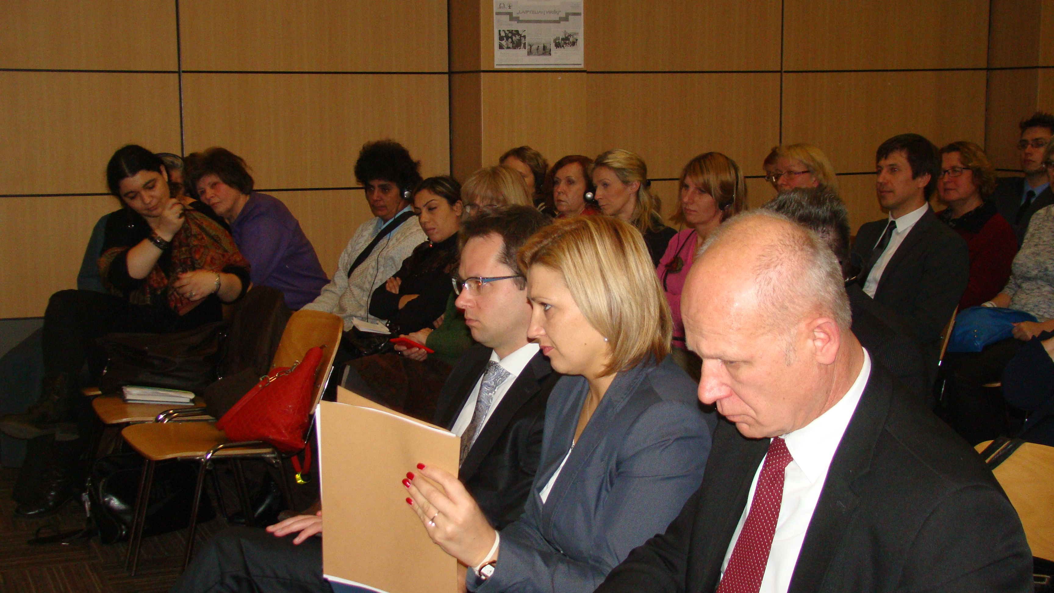
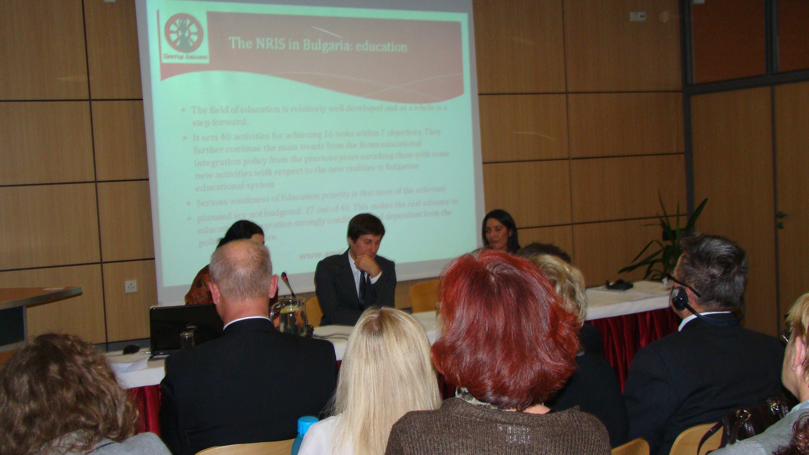

Activity type
Presentation of project
Date of the activity 23/05/2013
Location RCC, Vilnius
Description of the activity
Meeting with participants of International SOCIAL PLATFORM networking conference on “Social investment under the Lithuanian EU Presidency” building alliances between European and Lithuanian social civil society organizations – “field visit to grassroots organization”
Participants
Members of European and Lithuanian social civil society organisations
Evidences Meeting minutes
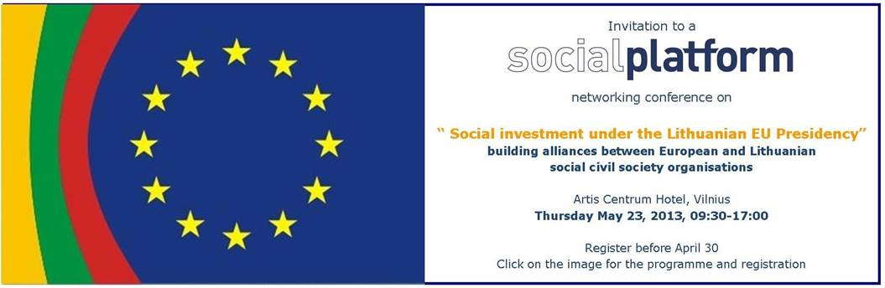

Activity type
Presentation of project
Date of the activity
26.04.2013
Location
RCC, Metalo str. 23 A Vilnius
Description of the activity
The Annual meeting of RCC founders: Ministry of Culture of Lithuania, Vilnius Municipality, Lithuanian Children’s Fund and Lithuanian Gypsy Association "Gypsy Fire
Participants 10
Evidences Minutes of the Annual meeting (attached)
Activity type
Presentation of project
Date of the activity
30.09.2013
Location
RCC, Metalo str. 23 A Vilnius
Description of the activity
Meeting with representatives of German Trade Union of Social workers

Participants :12
Evidences : List of attendance (attached)
Activity type :Presentation of project
Date of the activity: 06.10.2013
Location: RCC, Metalo str. 23 A Vilnius
Description of the activity - Meeting with representatives of Lithuanian Association of Education.
Participants 10
Evidences :List of attendance (attached)

